Project Plan

### **Current Progress**

Currently, the program can read in one PDF template and output a DMMR Report document. The program can populate all the fields except for the medication table on page 2 of the report.

## Implementing a graphical interface

This stage involves adding an interface to the program. This interface would allow the modification of values extracted from the PDF (via a form) before they are inserted into the DMMR Report document. The addition of this form would allow the processing of PDFs that might have slightly different formatting.

An example mock-up of a form can be seen below.

## Adding Second PDF Template

This stage would include adding the parsing of the second PDF template.

## Packing the Application

For the application to be easily installed on other computers, it needs to be packaged. This packaging stage would include cleaning up the code and converting the Python files into an installer.

# Cost

The agreed price for the program prior to our discussion was **$100.** Here is the breakdown of the additional stages and the new total.

Implementing a graphical interface ………………………….………………… **$30** (1.5 – 2.0 hours)

Adding Support PDF template ………………………………………………… **$40** (2.0 –3.0 hours)

Packing the application ………………………………………………………... **$20** (1.0 hour)

---------------------------------------------------------------------------------------------------------------------------

Total (Including the $100) …………………………………………………….. **$190**

# Other Options

## Azure Optical Character Recognition

Microsoft offers an online service which uses AI to extract text from. I would need to do further research to determine exactly how this process works. The pricing is as follows:

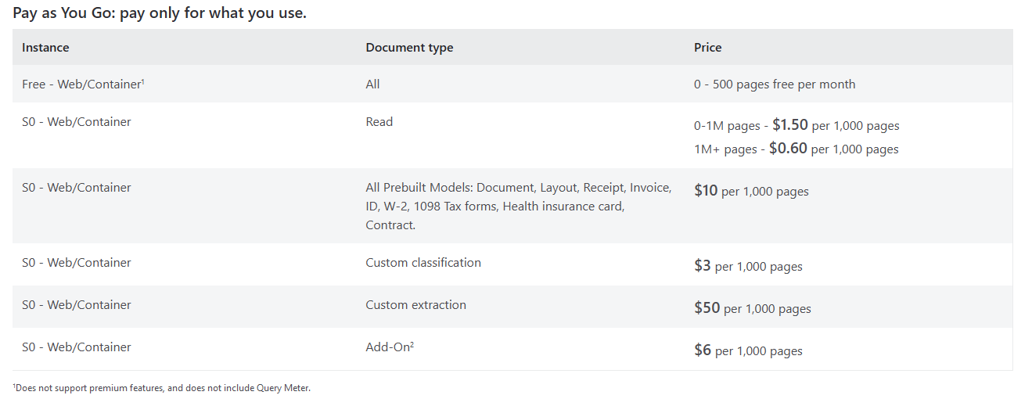

I would estimate that it would be $1.50 a month to use this service on top of the setup costs which, without doing further research, I do not feel comfortable estimating.